To achieve the tasks you've outlined, you'll need to use AWS Management Console or AWS CLI to create a security group, launch an instance, attach the security group to the instance, and assign an Elastic IP to it. Here's a step-by-step guide using AWS CLI:

### Step 1: Create a Security Group

1. *Create the security group:*

sh

aws ec2 create-security-group --group-name MySecurityGroup --description "Security group for SSH, HTTP, and HTTPS"

Note the GroupId from the output as you'll need it in the next commands.

2. *Add SSH, HTTP, and HTTPS rules:*

sh

aws ec2 authorize-security-group-ingress --group-id <GroupId> --protocol tcp --port 22 --cidr 0.0.0.0/0

aws ec2 authorize-security-group-ingress --group-id <GroupId> --protocol tcp --port 80 --cidr 0.0.0.0/0

aws ec2 authorize-security-group-ingress --group-id <GroupId> --protocol tcp --port 443 --cidr 0.0.0.0/0

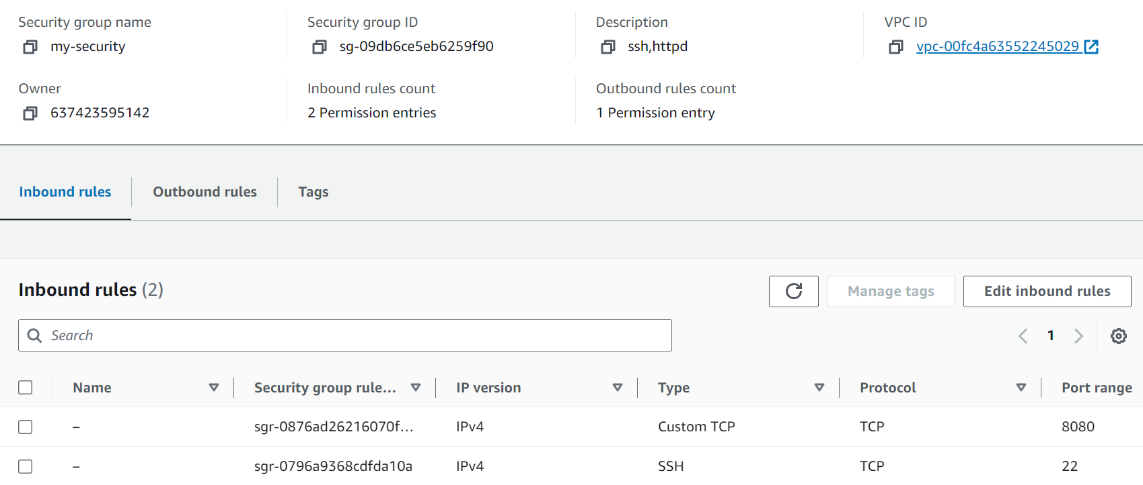

### Step 2: Launch an EC2 Instance

1. *Launch the instance:*

sh

aws ec2 run-instances --image-id <ami-id> --count 1 --instance-type t2.micro --key-name <your-key-pair> --security-group-ids <GroupId>

Replace <ami-id> with the AMI ID of your desired operating system, <your-key-pair> with your key pair name, and <GroupId> with the security group ID created earlier. Note the InstanceId from the output.

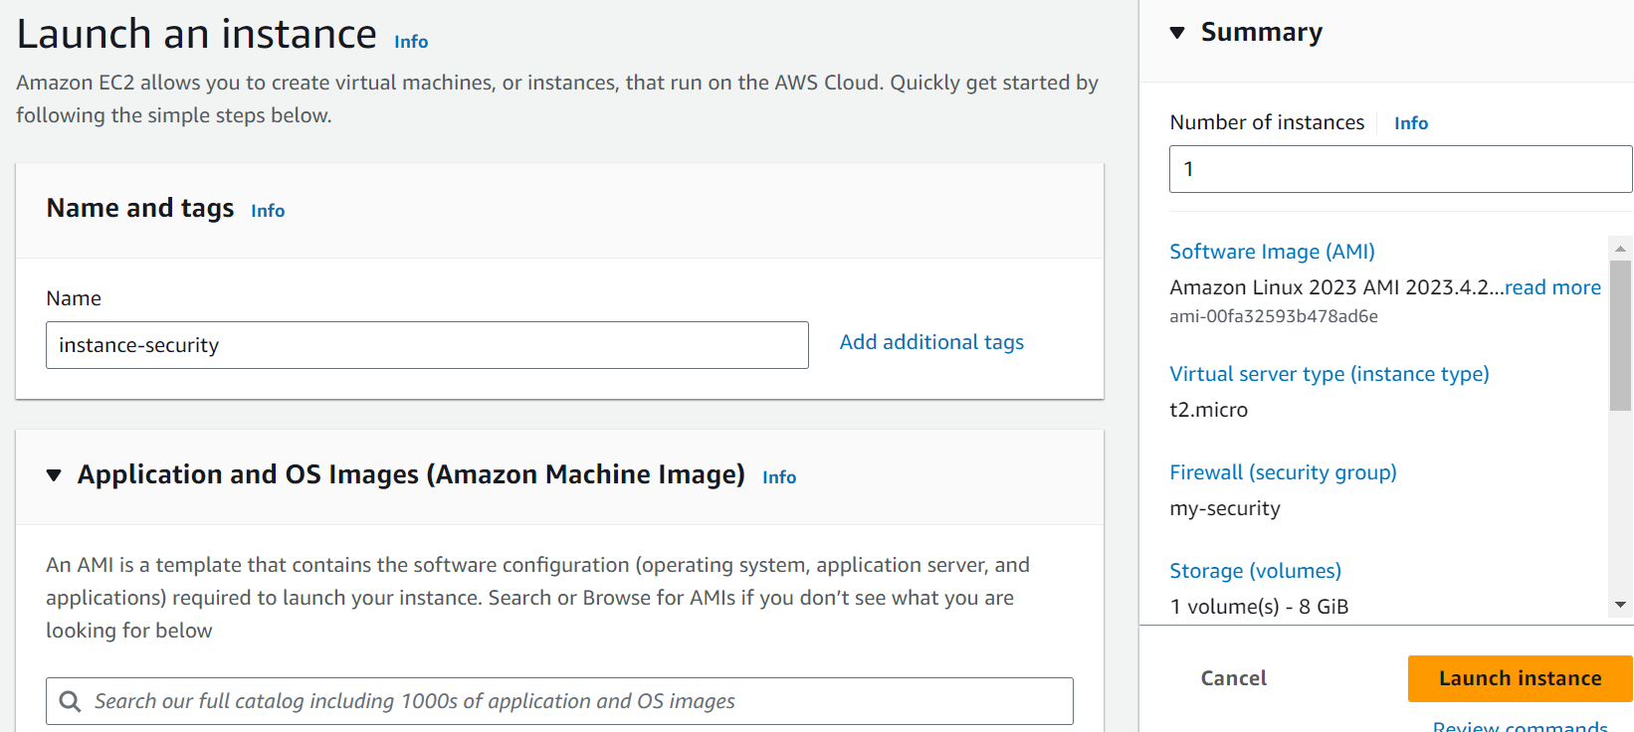

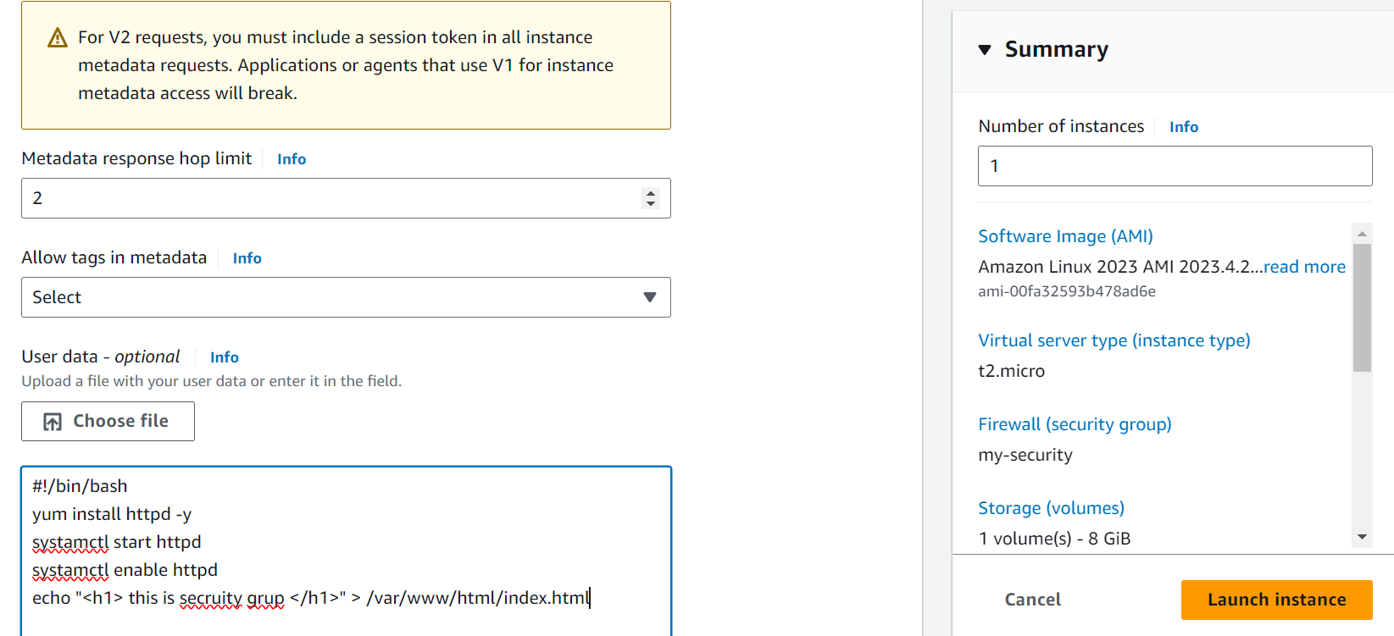

Step 3: Allocate and Associate an Elastic IP

1. *Allocate an Elastic IP:*

sh

aws ec2 allocate-address

Note the AllocationId from the output.

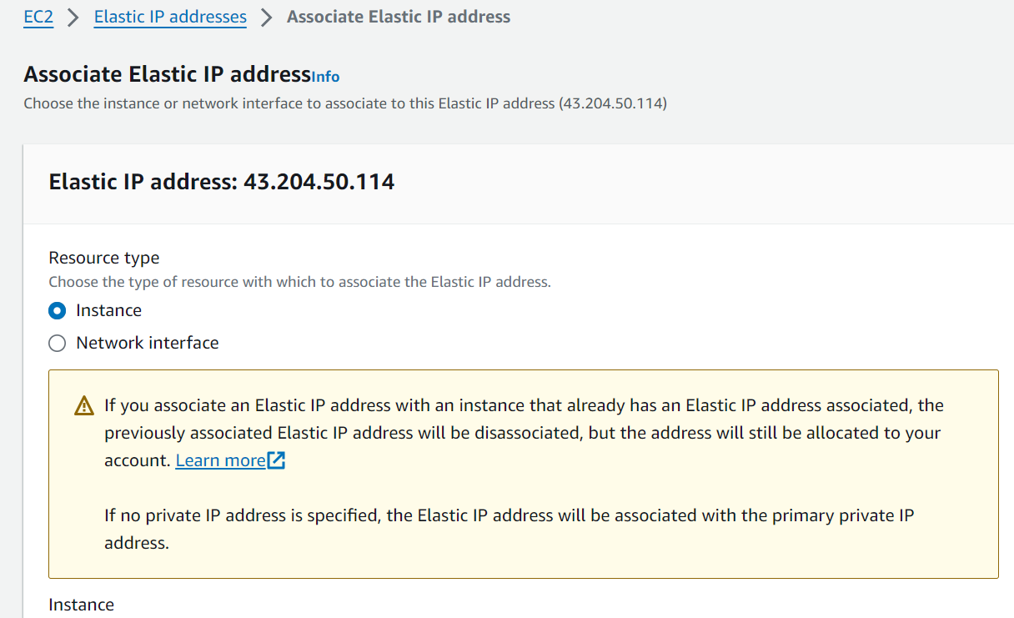

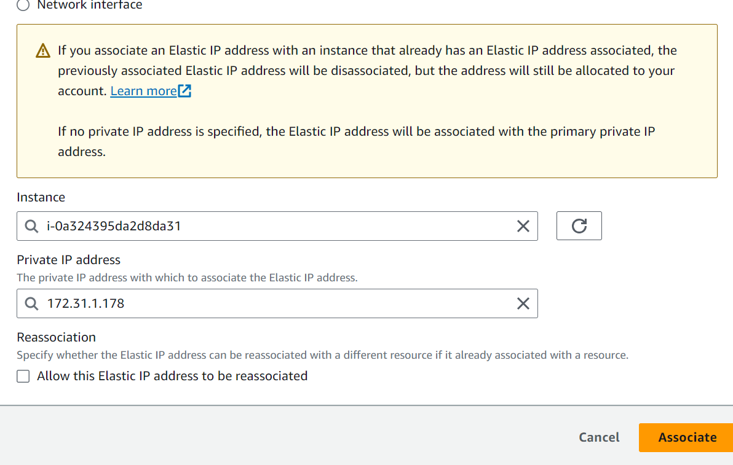

2. *Associate the Elastic IP with the instance:*

sh

aws ec2 associate-address --instance-id <InstanceId> --allocation-id <AllocationId>

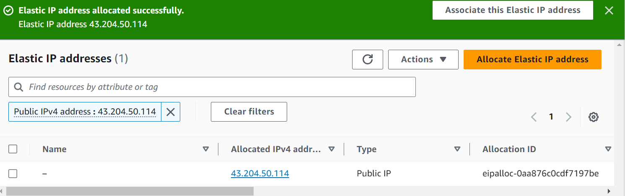

Replace <InstanceId> with the instance ID from the launch instance step and <AllocationId> with the allocation ID from the Elastic IP allocation step.

### Summary of Commands

Here's a summary of all the commands together for reference

# Create a security group

aws ec2 create-security-group --group-name MySecurityGroup --description "Security group for SSH, HTTP, and HTTPS"

# Add rules to the security group

aws ec2 authorize-security-group-ingress --group-id <GroupId> --protocol tcp --port 22 --cidr 0.0.0.0/0

aws ec2 authorize-security-group-ingress --group-id <GroupId> --protocol tcp --port 80 --cidr 0.0.0.0/0

aws ec2 authorize-security-group-ingress --group-id <GroupId> --protocol tcp --port 443 --cidr 0.0.0.0/0

# Launch an EC2 instance

aws ec2 run-instances --image-id <ami-id> --count 1 --instance-type t2.micro --key-name <your-key-pair> --security-group-ids <GroupId>

# Allocate an Elastic IP

aws ec2 allocate-address

# Associate the Elastic IP with the instance

aws ec2 associate-address --instance-id <InstanceId> --allocation-id <AllocationId>

Make sure you replace placeholders (<GroupId>, <ami-id>, <your-key-pair>, <InstanceId>, <AllocationId>) with your actual values.